- Extra change of clothes (shirt, pants, underwear,and socks in a bag labeled with your child’s name)
- Small Blanket for quiet time in a plastic bag labeled with your child’s name)
- Labeled water Bottle (water fountains will only be used to fill a bottle or cup)
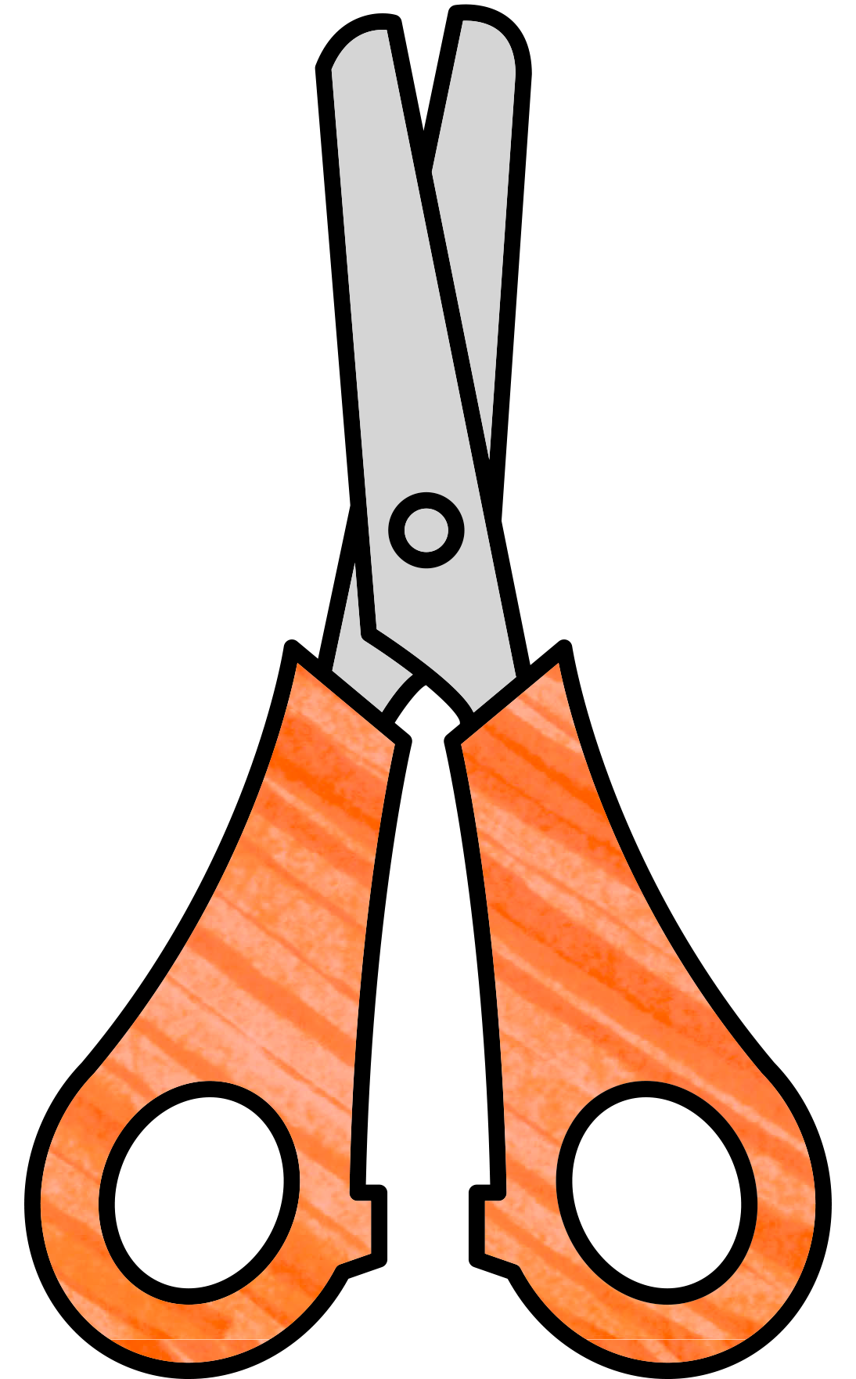
- Hand Sanitizer
- Lysol Disinfectant spray
- 2 containers Disinfectant Wipes
- 1 box Ziploc sandwich bags
- 1 box Ziploc Gallon bags
- Kleenex
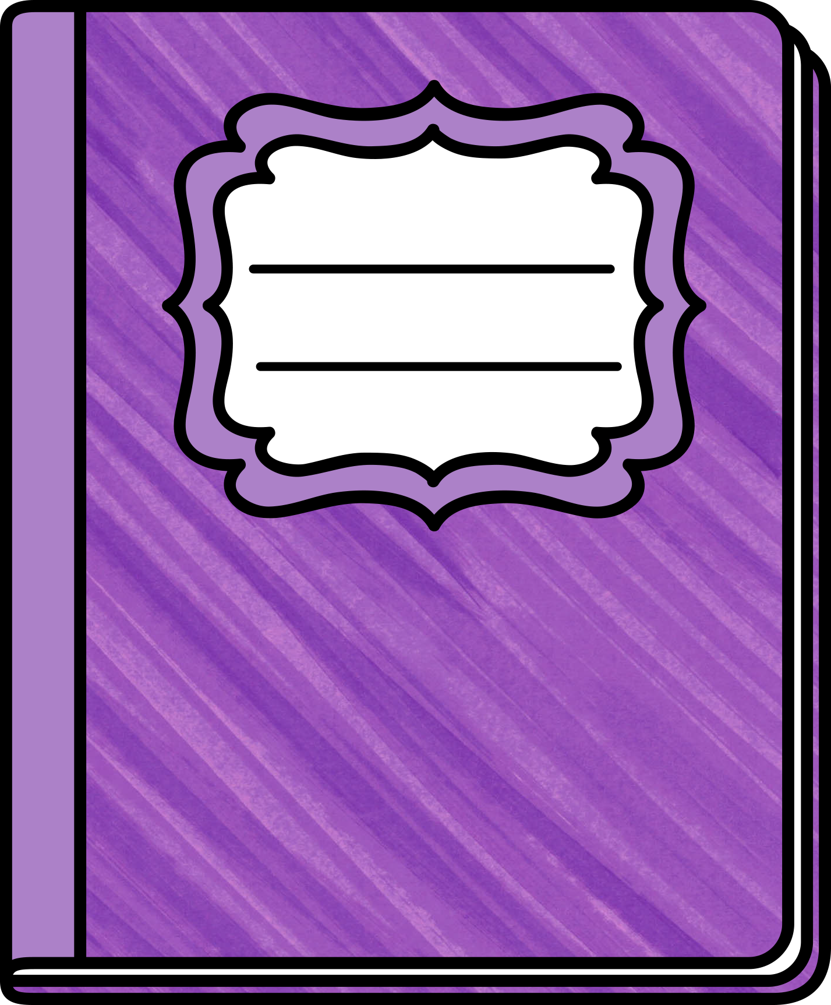
- Band-Aids
- Baby wipes
- Pencils
- Crayons
- Glue sticks
- Washable markers
- Composition notebook
- Clear packing tape
- Masking tape
- Scotch tape
- 1 Pack of copy paper
- Construction paper
- Play-doh
- Chalk

